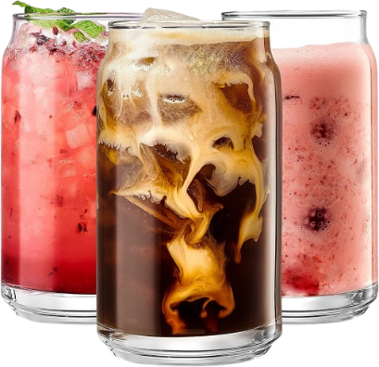
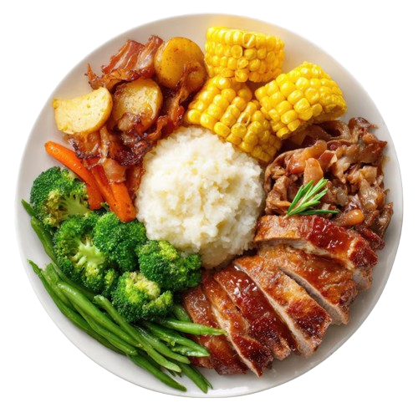
$5
$8
$10

Lemonade

Mineral Water

Smoothie

+927 374 1039
www.website.com
FREE DELIVERY
DRINKS
$10
$10
$12
$14
$15

Fried Rice
Avocado Toast
Vegetable Salad
Spaghetti Pasta
Cheesy Pizza

FOOD MENU
MAIN COURSE
Restaurant

